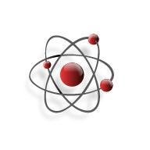**Name** _______________________________________________ **Date** _______________

**Structure of Matter**

**Question:** How are molecules put together?

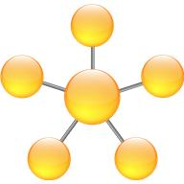

**Materials:**

Toothpicks

Colored Marshmallows (small)

Pencil, Crayons/Markers, ruler

**Procedure:**

1. With a partner create the molecules that are given in the chart below. Make sure that all of the same molecules are the same color. For example if you are doing H2O then make sure that your 2 Hydrogen marshmallows are one color and your Oxygen atom is another color.
2. Draw the molecules that you have created in the space beside each of the molecules given.   
   -*Label each atom.  
   -Color like atoms the same. Example both Hydrogen atoms in water would have the same color.  
   -You must use a ruler to draw the toothpick bonds or there will be points deducted!*

|  |  |
| --- | --- |
| **Substance and Makeup** | **Drawing of your Marshmallow Molecules** |
| CO2  Carbon Dioxide |  |
| SiO2  Silicon Dioxide  Glass, Sand, Quartz |  |
| CH4 |  |
| Water  H2O  CO  Carbon Monoxide |  |
| NH3  Ammonia |  |
| C2H6  Ethane |  |
| NaHCO3  Sodium Bicarbonate  Baking Soda |  |
| H2SO4  Sulfuric Acid |  |

**Conclusion:**

1. What do the letters in the formula represent? _________________________________________
2. What do the numbers in the formula tell you? _________________________________________
3. What does each individual marshmallow represent? ____________________________________
4. What do the toothpicks represent? _________________________________________________

***For the questions below use a piece of notebook paper. Please write in complete sentences and restate the question in your answer!***

1. Which molecules were the easiest to make? Why were they easy to make?
2. Which were the most difficult to create? Why do you think they were they the most difficult?
3. Were any of these molecules compounds? How do you know?
4. Were any of these molecules elements? How do you know?