**Physical and Chemical Changes and Properties of Matter Worksheet**

**Classify the following as chemical change (cc), chemical property (cp), physical change (pc), or physical property (pp).**

1. __**pp**__ Heat conductivity 8. __**cp**__ Combustible

2. __**cp_**_ Silver tarnishing 9. __**pc**__ Water freezing

3. __**pc**__ sublimation 10. _**cc**__ Wood burning

4. __**pc**__ magnetizing steel 11. _**cp**__ Acid resistance

5. __**pp**__ length of metal object 12. _**pp**__ Brittleness

6. __**pc**__ shortening (butter) melting 13. _**cc**__ Milk souring

7. __**cc**__ exploding dynamite 14. _**cc**__ baking bread

**Identify the following as being true or false to the left of the sentence.**

___**T**__ 15. A change in size or shape is a physical change.

___**T**__ 16. A chemical change means a new substance with new properties was formed.

___**F**__ 17. An example of a chemical change is when water freezes.

___**T**__ 18. When platinum is heated, then cooled to its original state, we say this is a physical change.

___**F**__ 19. When milk turns sour, this is a physical change because a change in odor does not indicate a chemical change.

___**T**__ 20. When citric acid and baking soda mix, carbon dioxide is produced and the temperature decreases. This must be a chemical change.

**Identify each of the following as a physical or chemical change.**

21. __**C**___ You leave your bicycle out in the rain and it rusts.

22. __**P**___ A sugar cube dissolves.

23. __**C**___ Scientist break-up water into oxygen and hydrogen gas.

24. __**C**___ Burning coal for a barbecue.

25. __**P**____ Trimming a bush because it has grown too tall.

**Classifying Matter Worksheet**

**Classify each of the following substances as an element, a compound, a solution (homogenous mixture), or a heterogeneous mixture.**

1. Sand **HET. M** 2. Salt **C** 3. Pure Water **C**

4. Soil **HET M.** 5. Soda just opened **S** 6. Pure air **M (probably HET.)**

7. Carbon Dioxide **C** 8. Gold **E** 9. Brass **S (metal alloy is hom. Mix)**

10. Oxygen **E** 11. Italian Salad Dressing **HET. M** 12. Salt Water **S**

13. Raisin Bran **HET M.** 14. Silver **E** 15. Lithium Iodide **C**

16. Apple Pie **HET M.** 17. Kool Aid **S** 18. Sugar Water **S**

19. Chocolate chip Cookie **HET. M** 20. Gatorade **S** 21. Gold **E**

22. tacos **HET. M** 23.Lead **E** 24. Caesar Salad **HET. M**

25. Calcium **E** 26. Whole Milk **S** 27. Skim Milk **S**

28. hydrogen peroxide **C** 29. Potassium **E** 30. Sugar **C**

31. Raisin Bran Cereal with Milk **HET. M** 32. Raisin Bran Cereal without Milk **HET. M**

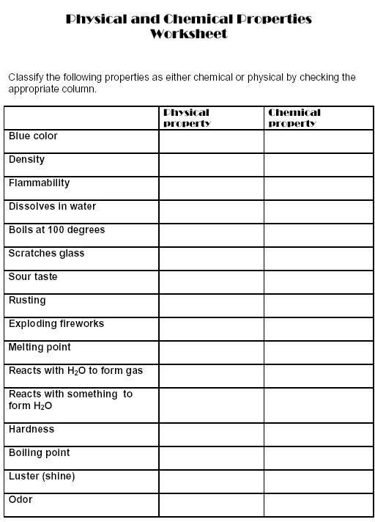

|  |
| --- |
|  |
|  |
|  |
|  |
|  |
| **PP** |
| **PP** |
| **CP** |
| **PP** |
| **PP** |
| **PP** |
| **PP (or CP? It’s due to CC)** |
| **CP** |
| **CP** |
| **PP** |
| **CP** |
| **CP** |
| **PP** |
| **PP** |
| **PP** |
| **PP? (but may be due to CC)** |
|  |

**Vocabulary Cards**

Use the example below, make vocabulary cards for the following words on the bottom and back of this paper:

Compound

Mixture

Pure Substance

Element

Matter



**Write the definition in this square**

**Use the word in a sentence in this square**

**Draw an illustration (picture) for the word in this square**

Identify each of the following as an example of a **P**hysical **P**roperty or a **C**hemical **P**roperty.

1. Silver tarnishes when it comes in contact with hydrogen sulfide in the air.

**CP**

1. A banana is yellow.

**PP**

1. A sheet of copper can be pounded into a bowl.

**PP**

1. Barium melts at 725 C.

**PP**

1. Gasoline is flammable.

**CP**

1. A diamond is the hardest natural substance.

**PP**

1. Helium does not react with any other element.

**CP**

1. A bar of lead is more easily bent than is a bar of aluminum of the same size.

**PP**

1. Potassium metal is kept submerged in oil to prevent contact with oxygen or water.

**CP**

1. An apple will turn brown is left in oxygen.

**CP**

1. Diamond dust can be used to cut or grind most other materials.

**PP**

1. Acid in tomato sauce can corrode aluminum foil.

**CP**

1. Rocks containing carbonates can be identified because they fizz when hydrochloric acid is applied.

**CP**

1. A piece of charcoal, which is mostly the substance carbon, glows red, gives off heat, and becomes a gray ash when it is burned.

**CP**