**Mon Phase Practice** Name_________________

***Use the moon phase chart to write the letter of the correct phase for the diagram 1 – 8.***

|  |  |  |  |  |  |  |  |
| --- | --- | --- | --- | --- | --- | --- | --- |
| **A**  New  Moon | **B**  Waxing Crescent | **C**  First Quarter | **D**  Waxing Gibbous | **E**  Full  Moon | **F**  Waning Gibbous | **G**  Third Quarter | **H**  Waning Crescent |
| Moon.Phase1.New | Moon.Phase2.Wax.Cresc | Moon.Phase3.1st.Qtr | Moon.Phase4.Wax.Gibb | Moon.Phase5.Full | Moon.Phase6.Wan.Gibb | Moon.Phase7.3rd.Qtr | Moon.Phase8.Wan.Cresc |



**Diagram A**

Sun

Sun                Moon     Earth           **(Figure C)**

**Diagram B**

Sun

Sun                Moon     Earth           **(Figure C)**

______ 1. Moon phase for **A**, ______ 2. Moon phase for **B.**

**Diagram D** Sun

Sun                Moon     Earth           **(Figure C)**

**Diagram C**

Sun

Sun                Moon     Earth           **(Figure C)**



______ 3. Moon phase for **C.** ______ 4. Moon phase for **D.**

**Diagram F**

Sun

Sun                Moon     Earth           **(Figure C)**



**Diagram E**

Sun

Sun                Moon     Earth           **(Figure C)**



______ 5. Moon phase for **E.** ______ 6. Moon phase for **F.**

**Diagram H**

Sun

Sun                Moon     Earth           **(Figure C)**

**Diagram G**

Sun

Sun                Moon     Earth           **(Figure C)**





______ 7. Moon phase for **G.** ______ 8. Moon phase for **H.**

**Diagram Z**

Sun                Moon     Earth           **(Figure C)**



____ 9. . What would you experience because of the arrangement of the Sun, Moon, and Earth shown in diagram Z?

1. Very high, high tides because of the sun and moon’s gravity.
2. Very low, high tides because of the sun and moon’s gravity.
3. Only high tides because the sun and moon pull giant bulges of water.
4. Only low tides because the sun and moon’s gravity cancel each other out.

***Use the diagram below for questions 6 – 9. This diagram is asking for seasons in North Carolina. Do not use “N”or “S”. These letters show direction North and South.***

**B**

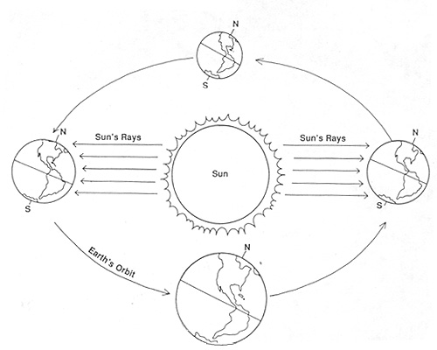

**C**

**D**

**A**

____ 10. Which globe shows the correct position of the globe during Spring Equinox in North Carolina?

____ 11. Which globe shows the correct position of the globe during Winter Solstice in North Carolina?

____ 12. Which globe shows the correct position of the globe during Fall Equinox in North Carolina?

____ 13. Which globe shows the correct position of the globe during Summer Solstice in North Carolina

14. Why do we have seasons?

15. Why do we have moon phases?

16. Why do we not have a solar eclipse once a month?

17. Why do we have day and night?

18. What is a comet?

19. What makes up our Solar System?