Physical and Chemical Changes Lab Name__________________________________
Purpose: To investigate combined substances so that we can practice classifying changes as physical or chemical.
Problem: Will the mixture of specific substances cause a chemical or physical change?
Background Information: In chemistry, the term change can refer to both physical and chemical changes. In the simplest sense, a physical change is a change in the form of the original substance. A chemical change is a change in the composition of the original substance. A chemical change is also called a chemical reaction.
Chemical Changes
Chemists have developed a list of common signs that may indicate the occurrence of a chemical change. These include:
1. Bubbles of gas appear
2. A precipitate (solid) forms
3. An unexpected color change occurs
4. Gain or release of energy (heat or light)
5. A change in volume occurs
6. A change in electrical conductivity occurs
7. A change in melting point or boiling point occurs
8. A change in odor or taste occurs
9. A change in a distinctive chemical or physical property occurs; not easily reversed

Physical Changes
Physical changes occur when objects undergo a change that does not change their chemical nature. A physical change involves a change in physical properties. Physical properties can be observed without changing the type of matter. Examples of physical properties include: texture, shape, size, color, odor, volume, mass, weight, and density. Change of state (ie. solid to liquid). And…
• Physical deformation (cutting, denting, stretching, etc.)
• Physical relocation (moving an object)
• Mixing sugar with water to dissolve sugar in the water is a physical change. However, if one baked a cake with flour, water, sugar, and other ingredients, new substances would appear. Chemical reactions occur in the baking process, and the changes are chemical changes.

Lab Experiment #1 The Blob
Prediction: What will happen when corn starch is mixed with water?
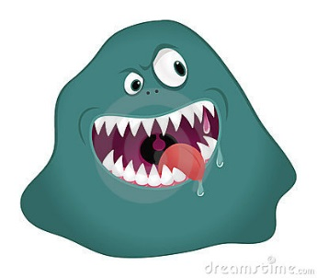
If_____________________________________________________then____________________________________________________________________________because________________________________________________________________________________________________________________________________________________
Materials: cornstarch, water, cup, stir stick
Procedure
1. Place 30 mL of cornstarch in a cup
2. Add 10 mL of water and stir well
3. Place some of the mixture on a table.
4. Touch it with your fingertips
Observations/Conclusions
Is the product a liquid or a solid? ____________________________________________________________________
Did you observe a physical or chemical change?________________________________________________________ Is the product a mixture or a pure substance? _________________________________________________________

Lab Experiment #2 Mr. Potato Head
Prediction: What will happen when you put 3 to 4 drops of iodine on a potato slice?
If_____________________________________________________then____________________________________________________________________________because________________________________________________________________________________________________________________________________________________
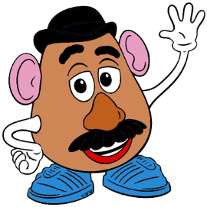
Materials: A small slice of potato, 3-4 drops of iodine
Procedure
1. Place 3-4 drops of iodine on a fresh potato slice
2. Observe the changes
3. Throw your potato away

Observations/Conclusions
List any changes you observed. _____________________________________________________________________
Is this a physical or a chemical change? _______________________________________________________________
What is your evidence? ___________________________________________________________________________
_______________________________________________________________________________________________

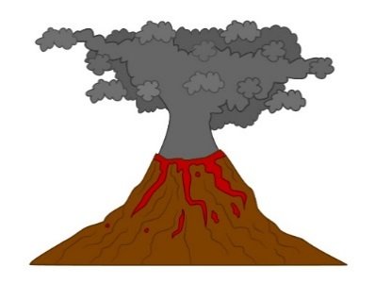

Lab Experiment #3 Vinegar & Baking soda
Prediction: What will happen when a crushed seltzer tablet is placed in water?
If_____________________________________________________then____________________________________________________________________________because________________________________________________________________________________________________________________________________________________
Materials: vinegar, baking soda, test tube
Procedure
1. Put 1cm of vinegar into a test tube
2. Put a small amount of baking soda (about ½ cm long) on a craft stick.
3. Place the baking soda carefully in the test tube.
4. After your observations are complete, pour the test tube contents into the sink, and rinse the test tube with water.
Observations/Conclusions
Did you observe a physical or a chemical change? ______________________________________________________
What is your evidence? ___________________________________________________________________________
_____________________________________________________________________________________________________________________________________________________________________________________________

Lab Experiment #4 Seltzer Tablet
Prediction: What will happen when a crushed seltzer tablet is placed in water?
If_____________________________________________________then____________________________________________________________________________because________________________________________________________________________________________________________________________________________________
Materials: alka seltzer tablet, test tube
Procedure
- Fill a test tube about ¼ full with tap water.
- Put a small piece of crushed seltzer tablet into the water in the test tube.
- Observe the substance.
- When you have completed your observations, pour the test tube contents into the sink, and rinse the test tube with water before putting it back into the rack.
Observations/Conclusions
What observations did you make? __________________________________________________________________ What type of change is illustrated? _________________________________________________________________ How do you know?_______________________________________________________________________________

Lab Experiment #5 Red Bull & Milk
Prediction: What do you think will happen when Red Bull is added or mixed with milk?
If_____________________________________________________then____________________________________________________________________________because________________________________________________________________________________________________________________________________________________
Materials: RedBull, milk, cups
Procedure
- Pour 50 ml of Red Bull into the 50 ml of milk.
- Wait for 5 minutes and observe the substance.
- Record your observations in the chart.

Observations/Conclusions
What type of change is illustrated? _________________________________________________________________ What is your evidence? ___________________________________________________________________________
Illustration: Draw a picture of the substance below.

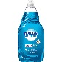
Lab Experiment # 6- Milk and liquid dish detergent
What do you think will happen when dish detergent is added or mixed with milk?
If__________________________________________then________________________________________________because________________________________________________________________________________________.
Materials: milk, toothpick, dish soap, food coloring, bowl
Procedure
1) Pour milk into the dish just enough to cover the bottom.
2) Drop a drop of each color of food coloring in 4 corners of the milk.
3) Dip the end of the toothpick into the dish soap and then into the center of 1 drop of colored milk. Don’t stir it!

Observations/Conclusions
What type of change is illustrated? _________________________________________________________________ What is your evidence? ___________________________________________________________________________
Illustrate what is happening to the milk below:

Lab Experiment #7 Barnacles May Be Jealous
Prediction: What will happen when a crushed seltzer tablet is placed in water?
If_____________________________________________________then____________________________________________________________________________because________________________________________________________________________________________________________________________________________________
Materials: 40 mL of skim milk, 10 mL of vinegar, 3 plastic cups, filter paper or coffee filter, plastic spoon, baking soda, 2 pieces of paper
Procedure
1. Pour about 40 mL of skim milk into a plastic cup. Add about 10 mL of vinegar and stir to mix.
2. Pour the mixture through a coffee filter into another cup.
3. Use a plastic spoon to scrape off the solid material that collects on the filter. Place this material in a third cup.
4. Add a pea-sized amount of baking soda to the third cup. Stir to mix.
5. Try sticking two pieces of paper together using this substance.
Observations/Conclusions
Is making glue an example of a physical change or a chemical change? _____________________________________ What evidence is there that a physical or chemical change has taken place? _________________________________
______________________________________________________________________________________________________________________________________________________________________________________________

