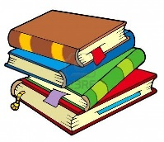
Reading Survey Name: __________________

- What kinds of texts do you like to read?

- What are some of your favorite books or other texts?

- Who is your favorite author? Why do you like his/her books?

- Which one best describes you? Check one.

______ I love reading, and I do it whenever I can.
______ I like to read, but I also like to spend time doing other things. I read sometimes.
______ Reading is okay. I do it when I have to.
______ I don’t really like reading.

- When you go to the library to choose a book, how do you decide if the book is too easy for you? How do you decide if it’s too hard?

- Once you choose a book, do you just dive right in to reading, or do you do anything before you start reading? (Ex. Skim the book for pictures, read the back cover, read table of contents, look at chapter lengths, etc.)

- What do you do when you come to a word that you can’t pronounce? What do you do if you don’t know the meaning of a word?

- Name the things you do well when you are reading.

- Name some things you’d like to do to become a better reader.

- How do you feel when you are reading?

- In your opinion, is it important to be a good reader? Why or why not?

