Part 6 -Transpiration
6.L.1.2- Explain the significance of the processes of photosynthesis, respiration and transpiration to the survival of green plants and other organisms.
Transpiration- The process in which water from the _________ is pulled through the ______. _____ in leaves ___________ through holes called ________. This pulls the water below it into the leaves. As _________ moves through the plant, it moves_________ and __________ through the plant.
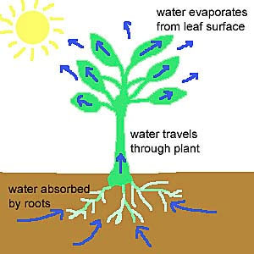
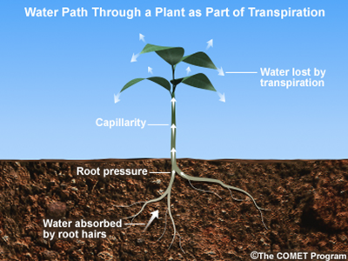
Review Questions
- Which of the following processes is used by plants to transport water from the roots to the leaves?
    - Photosynthesis
    - Respiration
    - Transportation
    - Digestion
- Which of the following is NOT a benefit of transpiration?
    - Moves water through the plant
    - Moves minerals through the plant
    - Moves sugar through the plant
    - Moves sunlight through the plant

