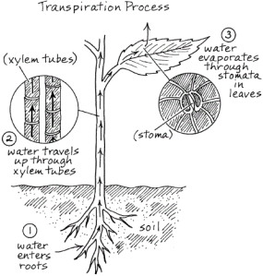

Video Notes:
How do water and minerals
get to the leaves?

What is cohesion?

How does cohesion relate to the movement of water through the plant?

What does a hot/dry environment do to the rate of transpiration?

How does a plant prevent excessive water loss?

What’s the tradeoff of the guard cells closing on the plant leaf?

Transpiration Lesson:
Show Transpiration Video http://youtu.be/mc9gUm1mMzc
Handout Transpiration Process
Show video again and have students fill in info as they watch.
Go over handout together as a class after

