What’s the Deal with WAVE Classification?
How are WAVES classified?
Waves can be classified by _______ they move through or by _____________ moves through them.
Classification of WAVES by __________________________
There are two classifications for waves based on what they move through:
- _______________ Waves
- _______________ Waves
What are mechanical WAVES?
_________________ waves are waves that can ________ move through a _________(through matter).
Mechanical waves require the ________of the _______to ______in order for energy to be transferred.
What are examples mechanical WAVES?
- water waves
- ________________
- _________ waves
- waves that travel down a _____ or _________
- All of these examples _________ move through _______________.
What is EMPTY SPACE?
- Empty space is space in which ____________ is present. Another name for this is a ________.
What are electromagnetic WAVES?
- _________ waves
- ___________
- ______ waves
- _______ light
- ________ rays
- __________
Classification of WAVES by HOW energy moves through them
There are two classifications for waves based on how energy moves through them:
- _____________________________ Waves
- _________________________ Waves
What are compressional/ longitudinal WAVES?
_____________waves in which the ________ of matter in the medium ______by pushing together and moving apart ______to the direction __________________travels are called compressional/longitudinal waves.
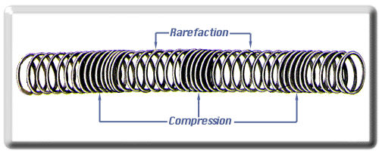
The place on the wave that is _________________ is called the ___________ and the place that is ___________ is the ______________.
What are examples of compressional/ longitudinal waves?
- _________ waves
- some waves in a ________
- some ________ waves (earthquake waves- primary waves, to be exact)
What are transverse WAVES?
_______ waves in which the particles of matter in the medium _______ by moving back and forth and __________ (at right angles) to the _________________ travels are called transverse waves.
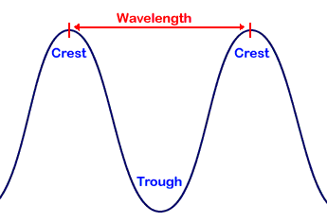
The __________ point of a transverse wave is the ____ and the _____ point is called a ______.
What are examples of transverse waves?
- _______ on a musical instrument
- waves on a _____
- some waves in a _______
- some _______ waves (earthquake waves- secondary waves, to be exact)____________ waves are ____________ waves that can travel without a _______through __________________.

